HSB – Office Visit Change Changes for Master List & Medical Document



*April 4, 2016*

Document Revision History

|  |  |  |  |
| --- | --- | --- | --- |
| Version | Date | Change Description | Author |
| 1.0 | 4/4/16 | Initial draft | Mandy Reimann |
|  |  |  |  |
|  |  |  |  |

Business Background / Current State:

The current method for handling the copay amount for Office Visit services has become problematic for when a plan has a different PCP and Specialist Office Visit copay, and the specific office visit service (such as Allergy OV or Chemotherapy OV) is not specified in a the plan’s previous benefit documentation (such as the SPD), then assumptions have to be made to determine if standardly a PCP or Specialist would perform the service. This is problematic for the following:

1. Sales/Account team is spending time trying to research the appropriate copay level to set (ie: either the PCP or Specialist).
2. Sales/Account team has to update the OV lines in eBenefitSync which is time-consuming.
3. Risk exists that if assumption to apply the PCP or Specialist Copay amount for a specific OV service is not correct, then there is potential to quote the benefit incorrectly.
4. Considerations:
   1. Some plans have specific OV copays for specific OV services. For example, regardless of the PCP or Specialist OV copays, a plan could have a Chiro OV copay that is completely different.
   2. The solution needs to satisfy the needs of the sales/account teams to efficiently create the plans, ensure that the Configuration Team has the appropriate information to set-up the plan, and that the Benefit Matrix clearly shows the appropriate benefit level for quoting.

Business Requirements:

1. Update the Master List, Medical Services, Office Visit Category:
   * 1. Change “Office Visit Charge” to “Office Visit Charge – PCP”
     2. Create a new option for “Office Visit Charge – Specialist”
     3. Add new services so that each Office Visit Charge now has a service line for “Office Visit Charge – PCP” and “Office Visit Charge – Specialist”
     4. Update the Apply Copay Type Column
        1. Each “Office Visit Charge – PCP” applies PCP option
        2. Each “Office Visit Charge – Specialist” applies Specialist option

**NOTE: for 1.1.3 and 1.1.4 – BA team will provide an updated excel file with all the service changes.**

Example:

* + Currently, there is one service line for “Orthotics, Office Visit Charge”

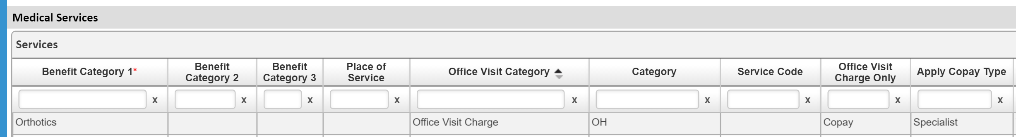

* + In the future there will be two service lines “Orthotics, Office Visit Charge – PCP” and “Orthotics, Office Visit Charge – Specialist”

|  |  |  |  |  |  |  |  |  |
| --- | --- | --- | --- | --- | --- | --- | --- | --- |
| BC1 | BC2 | BC3 | POS | Office Visit Category | Cat | SC | OV Charge Only | Apply Copay Type |
| Orthotics |  |  |  | Office Visit Charge – PCP | OH |  | Copay | PCP |
| Orthotics |  |  |  | Office Visit Charge – Specialist | OH |  | Copay | Specialist |

1. Update the Medical Document Design logic so that Cost Share Section, Copay List Repeater values for PCP and Specialist are automatically displayed appropriately in the Benefit Review Grid for each service line that has “Office Visit Charge – PCP” and “Office Visit Charge – Specialist”.

Example:

* + In the Medical Document, Cost Share section, Copay List Repeater, the user has entered a PCP copay value of $20.00 and a Specialist copay value of $30.00.
  + Therefore, in the Medical Document, Benefit Review Grid:
    - All service with “Office Visit Charge – PCP” should reflect $20.00 in the copay column
    - All services with “Office Visit Charge – Specialist” should reflect $30.00 in the copay column